Introductory Networking
DG Interns Hub | Week 1 | TryHackMe Room Writeup

Objective
Understand network communications and foundational protocols.

Activity summary
Completed introductory networking explanations and knowledge checks.

Key learning
IP addressing, network layers and common protocols.

Evidence
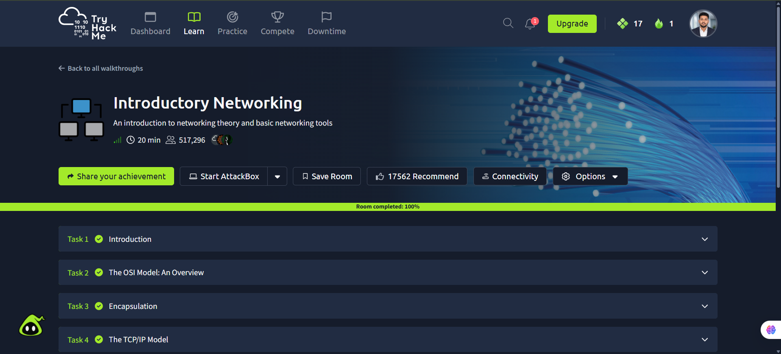
Screenshot: Introductory_Networking.png
Completion screenshot provided; the original step-by-step room answers were not included in the archive.

